Scoreboard Instructions – Bill Copeland Arena 2018
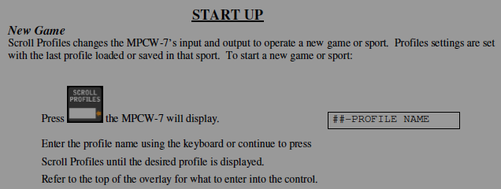
Keep Pressing to choose one of the options:
“1- HOCKEY” – for Hockey.
Scroll Profiles
[“96-Hockey” will NOT work with this controller]

“2-LACROSSE” (with 30 second shot clock)
[“92-Lacrosse” will NOT work with this controller]

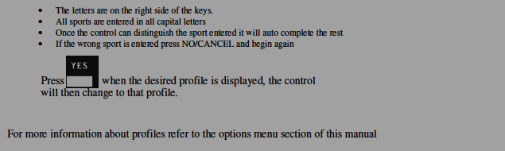
“3-RINGETTE” (with 30 second shot clock)

Disregard the word “Hockey” after selecting profile.
All Profiles are preset for 20 minute periods that can begin countdown immediately and can be changed with the following options.
PLEASE TURN CLOCK OFF WHEN FINISHED
**NOTE There is a new wireless controller for the Bill Copeland Score Clock.
For now … if it’s running time – to add a Penalty you need to stop the clock and add the penalty. The Arena Operations Coordinator is checking with the score clock manufacturer to find out how to add a penalty without stopping the clock.

