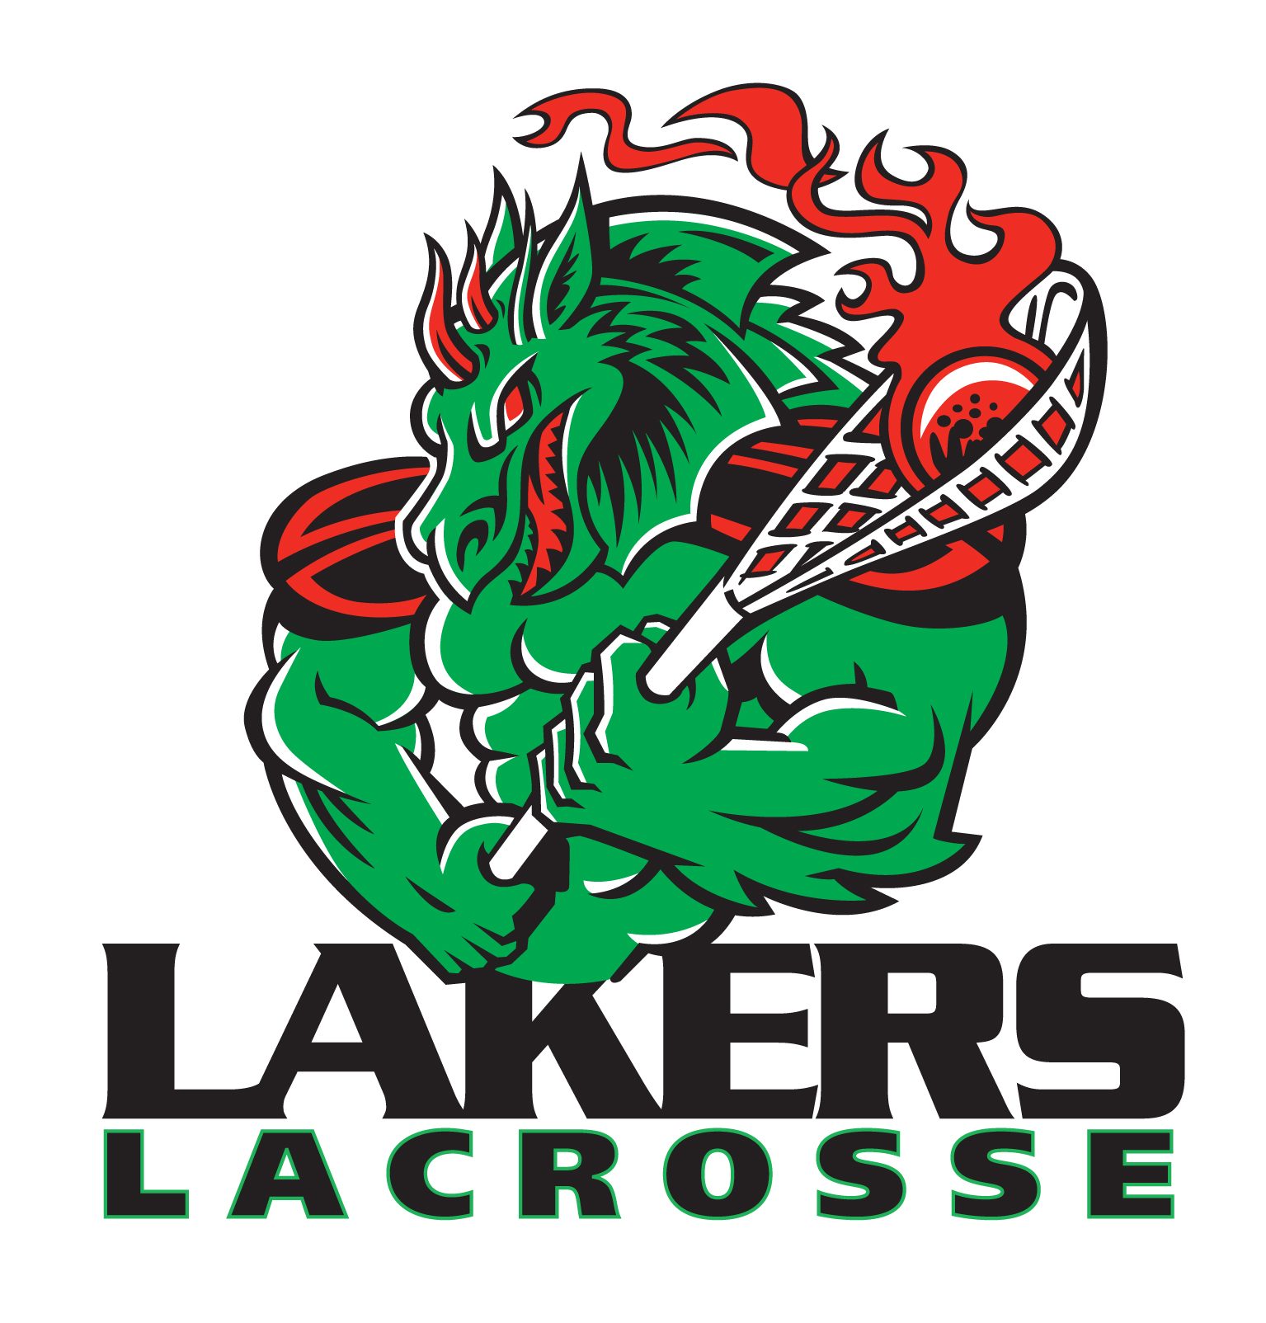

Code of Conduct

As a member of the Burnaby Minor Lacrosse Club I commit to the following:

Players
- I participate because I enjoy the game and I want to play, not simply because my parents or coaches want me to.
- I will abide by the rules of the game – both written as well as in the spirit in which they were intended.
- I will control and manage my temper and emotions - fighting and abusive or disrespectful language, gestures, or conduct by or between players, coaches, parents, spectators, and officials is unacceptable and is subject to suspension by the Burnaby Minor Lacrosse Club.
- I will respect my opponents and the game officials.
- I will always do my best and be a team player.
- I will remember that winning isn't everything - that doing my best, having fun, improving skills, and making friends are also important.
- I will acknowledge all good players/performances - those of my team and of my opponents.
- I will remember that coaches and officials are there to guide and assist me, and although, at times I may disagree, I will accept their decisions and treat them in a respectable manner.

Parents
- I will not force my child to participate.
- I will remember that my child plays sport for his/her enjoyment, not mine.
- I will encourage and insist that my child plays by the rules and resolves conflicts without resorting to hostility, abusive language, rude gestures, or violence.
- I will teach my child that doing one's best is the most important thing, and the only thing he or she can control.
- I will offer my son or daughter praise and encouragement for trying hard, doing their best, and competing fairly.
- I will never publically or privately ridicule or yell at my child or other children for making a mistake or losing a competition.
- I will remember that children learn best by example. I will acknowledge and applaud good players/performances by both my child's team and their opponents.
- I will never question the officials' judgment, honesty, or integrity in public.
- I will support all efforts to remove verbal and physical abuse from children's sporting activities both on and off the floor.
- I will respect and show appreciation for the volunteer coaches who give their time to provide sport activities for my child.
- I realize that I may be removed from a game, practice, or facility and possibly expelled from the association if I should behave in a manner deemed unacceptable by the coaches, game officials, spectators, or BMLC Executive.

Coaches
- I will refrain from using foul or negative language.

- I will not verbally or physically abuse a game official.

- I will demonstrate courtesy and respect for all players, spectators, officials and coaches, regardless of association.

- I will demonstrate good sportsmanship towards the opposing team and its spectators regardless of the circumstances,

- I realize that I may be removed from the game, practice, or facility and possibly expelled from Burnaby Minor Lacrosse if I should behave in a manner deemed unacceptable by the coaches, game officials, or spectators.

Team: ____________________________________________________________________________

Players Name:_______________________________________________________________________

Players Signature: ____________________________________________________________________

Parent: _____________________________________________________________________________

Parent: _____________________________________________________________________________

Coach: _____________________________________________________________________________

Date: _____________________________

